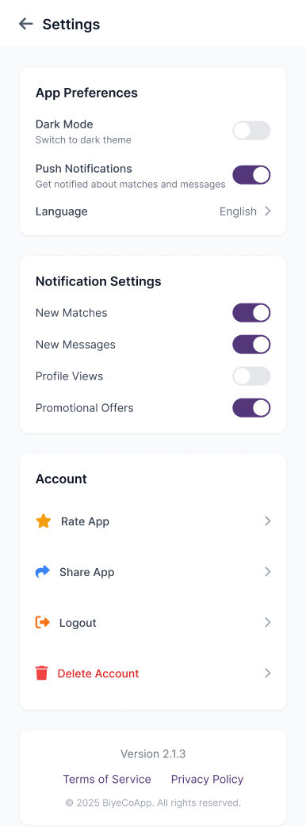
App Preferences

Theme
Light / Dark Mode
Choose how Biye Co feels — soft light or serene dark.

Notifications
Push Notifications 🔘
Stay updated when there’s a new match or message waiting.

Language
English ›
Select your preferred language.

⸻

Notification Preferences

New Matches — Get alerts when compatible profiles connect.
New Messages — Be notified when someone reaches out.
Profile Views — See who’s shown interest in you.
Special Updates — Hear about new features and limited-time offers.

⸻

Account

Rate Biye Co — Tell us how your journey feels.
Share Biye Co — Invite someone to begin their own.
Pause/ Logout — Step away securely, your data stays safe.
Delete Account — Permanently remove your profile (as per T&C guidelines).

